**Screen shots of output of Deploying ELK Stack on Docker Container:-**

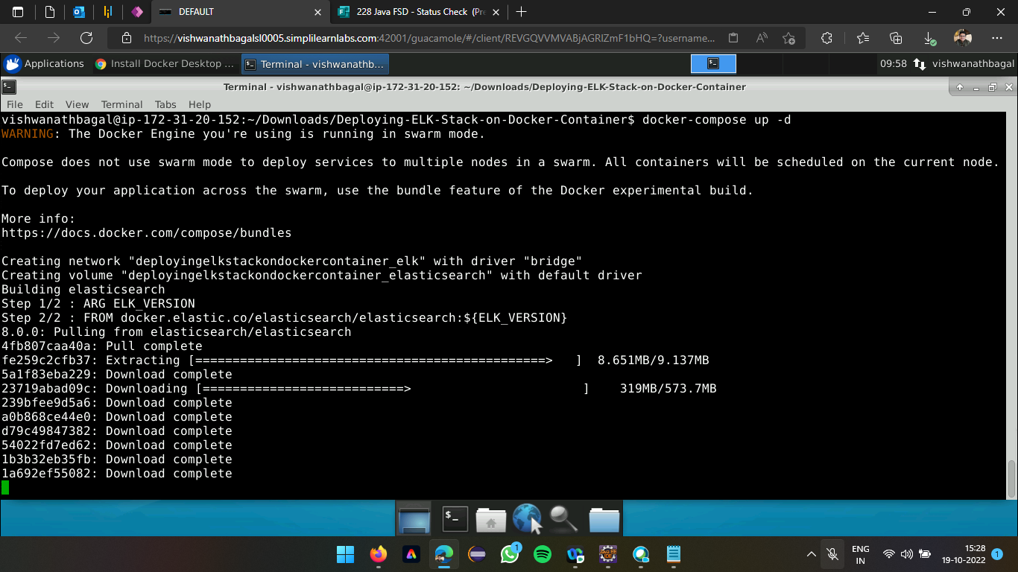

**Executing docker-compose up -d**

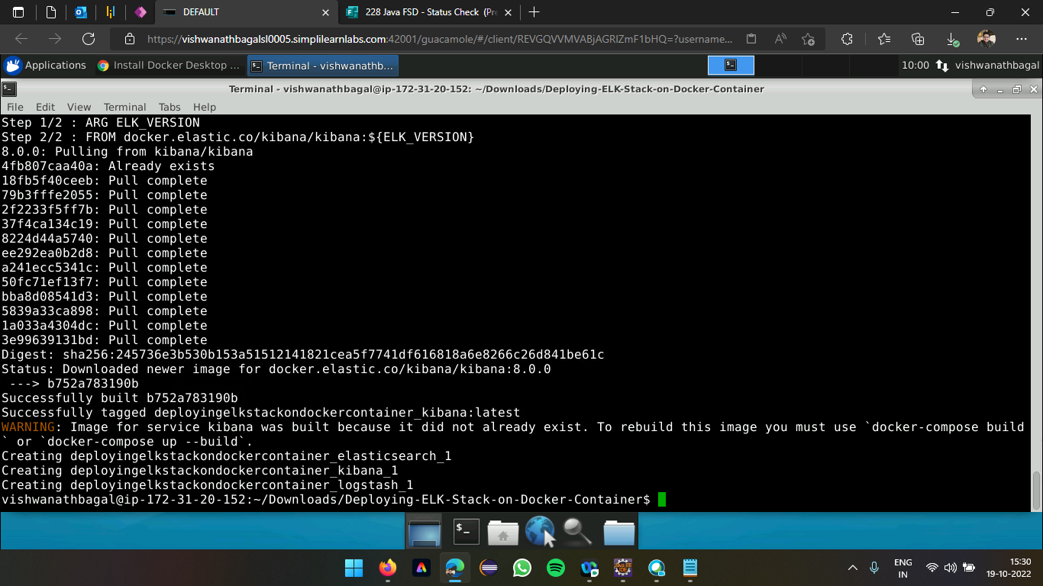

**Aggregating the containers (Elasticsearch, Logstash, Kibana)**

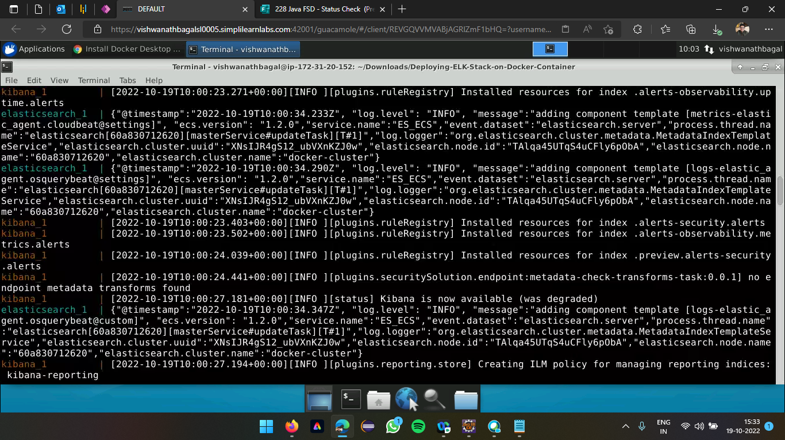

**Installation of resources for ELK (Kibana)**

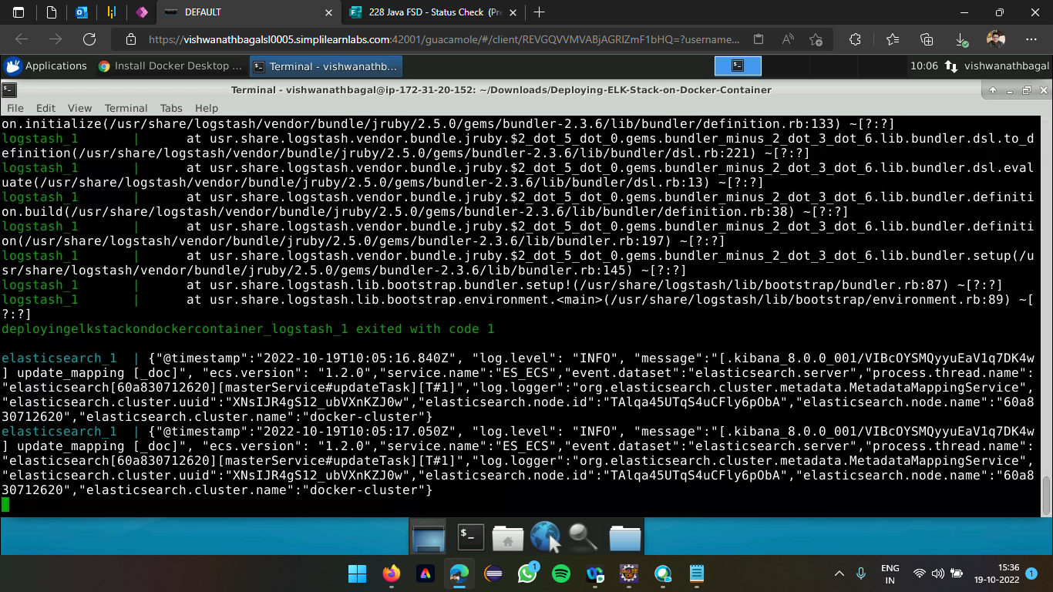

**Installation of resources for ELK (Logstash)**

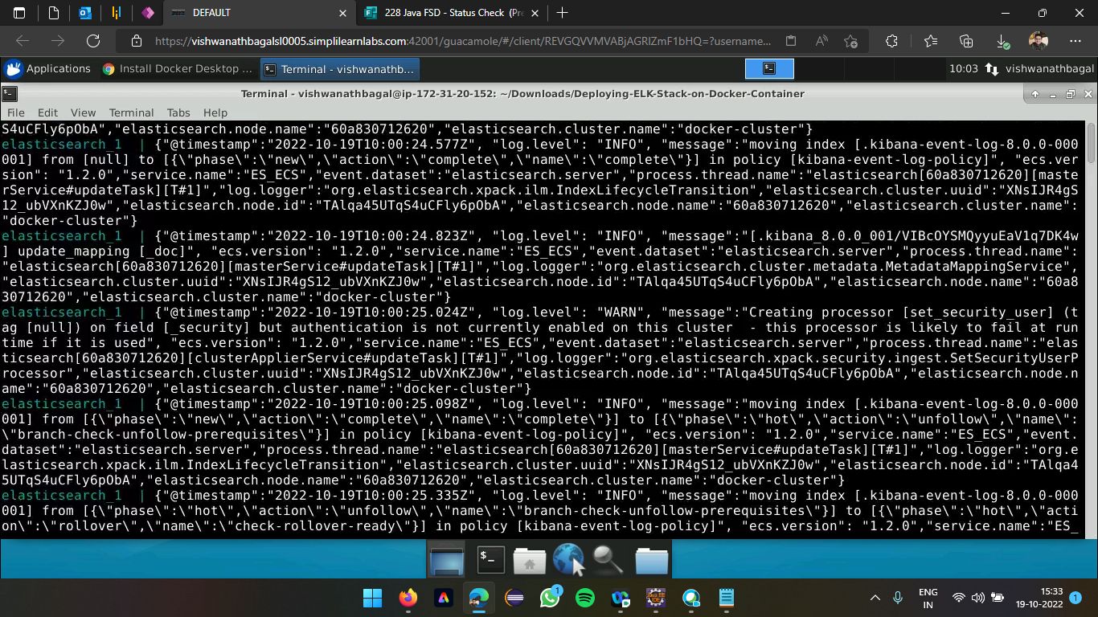

**Installation of resources for ELK (Elasticsearch)**

**Accessing the Kibana through browser using localhost:5601**

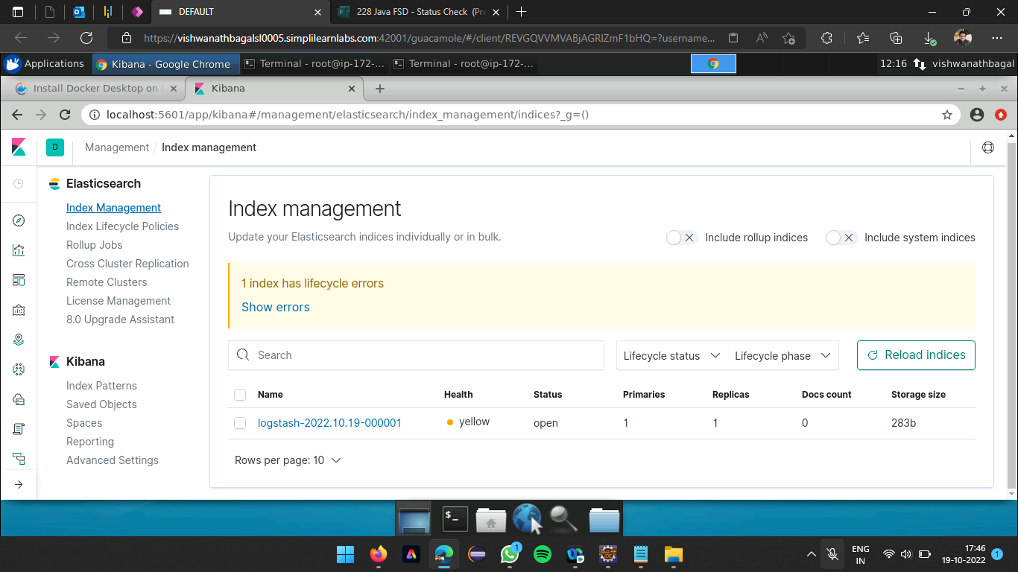

**Index management of Kibana displaying status of Logstash launched**

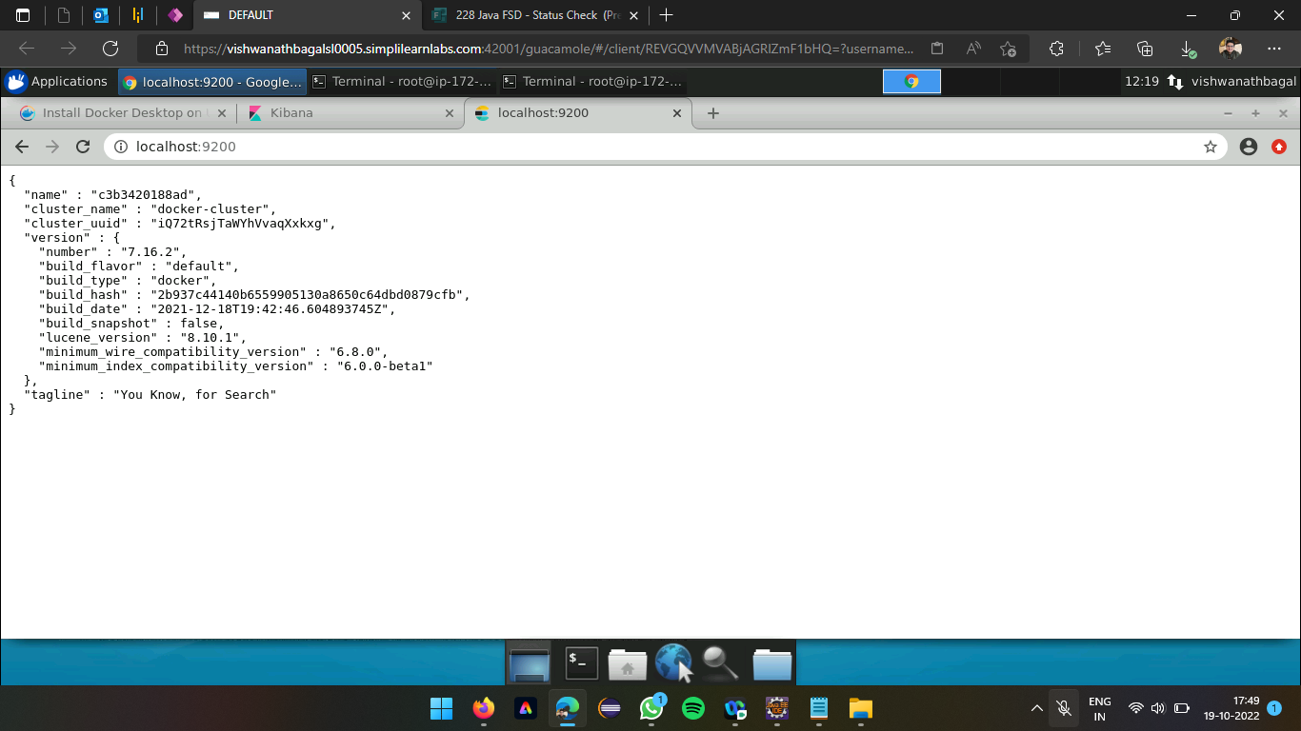

**Container details of Elasticsearch after resources installation**

